DESCRIPTION / SCOPE |  | PRODUCT LISTINGS |  | PRODUCTION PROCESS
${csProcessRisk_Group_Description} |  | ${csProcessRisk_Group_Listing} |  | ${csProcessRisk_Group_Process}

STORAGE CONDITIONS |  | SHELF LIFE |  | CCPS IDENTIFIED IN GROUP
${csProcessRisk_Group_StorageConditions} |  | ${csProcessRisk_Group_ShelfLife} |  | ${csProcessRisk_Group_CcpsPresent}

CURRENT HACCP TEAM
Name | Department | Qualification | Role
${csProcessRisk_Team_R}${csProcessRisk_Team_Name} | ${csProcessRisk_Team_Department} ${csProcessRisk_Team_Designation} | ${csProcessRisk_Team_Qualifications} | ${csProcessRisk_Team_Role}

HACPP GROUP FLOW
${csProcessRisk_Flow_File:height=20cm:width=18cm}

CCP Decision Tree
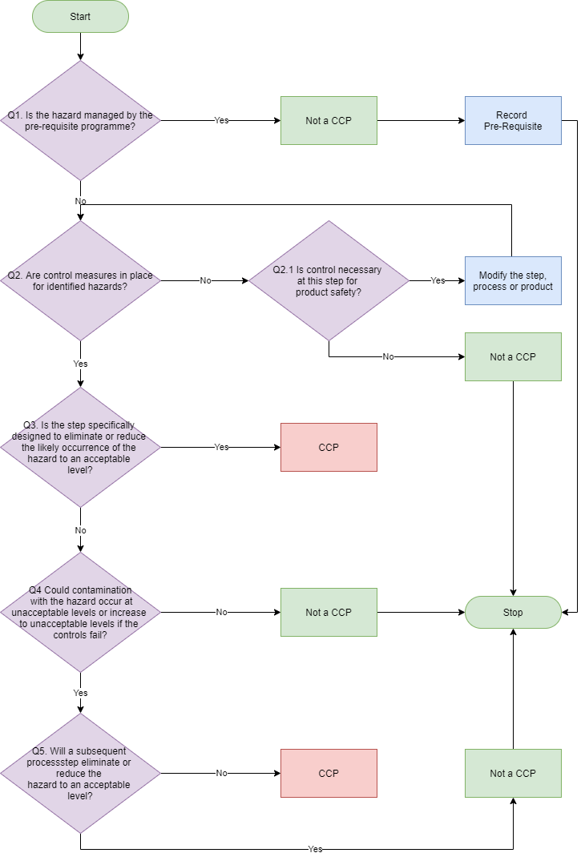

Likelihood Levels will be determined using the following definitions  Risk Level Definition  ${csProcessRisk_Rating_L_R}${csProcessRisk_Rating_L_Level} = ${csProcessRisk_Rating_L_Value} ${csProcessRisk_Rating_L_Description} |  | Risk Level x Severity Level = Hazard Score  1 2 3 4 5  1 1 2 3 4 5  2 2 4 6 8 10  3 3 6 9 12 15  4 4 8 12 16 20  5 5 10 15 20 25
Severity Levels will be determined using the following definitions  Risk Level Definition  ${csProcessRisk_Rating_S_R}${csProcessRisk_Rating_S_Level} = ${csProcessRisk_Rating_S_Value} ${csProcessRisk_Rating_S_Description} |  | Hazard Score RPN Level  1 – 2 Low  3 – 4 Medium  5 – 12 High  15 – 20 Very High  25 Extreme

PROCESS STEPS
Name | Description
${csProcessRisk_Steps_R}${csProcessRisk_Steps_Name} | ${csProcessRisk_Steps_Description}

PRE-REQUISITE PROGRAMME
Name | Description
${csProcessRisk_Reqs_R}${csProcessRisk_Reqs_Name} | ${csProcessRisk_Reqs_Description}

HAZARD ANALYSIS
Process Step |  | Hazard Type | Potential Hazard | Risk Rating  [L x S = RPN] | Pre-Requisites | Control measures | Q1 | Q2 | Q3 | Q4 | Q5 | CCP? | CCP ID
${csProcessRisk_Hazard_R}${csProcessRisk_Hazard_ProcessStepNo} | ${csProcessRisk_Hazard_ProcessStep} | ${csProcessRisk_Hazard_HazardType} | ${csProcessRisk_Hazard_Hazard}  ${csProcessRisk_Hazard_HazardDescription} | ${csProcessRisk_Hazard_HazardLikelihood} x ${csProcessRisk_Hazard_HazardSeverity} = ${csProcessRisk_Hazard_HazardRisk} | ${csProcessRisk_Hazard_HazardPrerequisites} | ${csProcessRisk_Hazard_HazardControls} | ${csProcessRisk_Hazard_CcpQ1} | ${csProcessRisk_Hazard_CcpQ2} / ${csProcessRisk_Hazard_CcpQ3} | ${csProcessRisk_Hazard_CcpQ4} | ${csProcessRisk_Hazard_CcpQ5} | ${csProcessRisk_Hazard_CcpQ6} | ${csProcessRisk_Hazard_CcpOutcome} | ${csProcessRisk_Hazard_CcpId}

CRITICAL CONTROL POINTS
Process Step Number |  | CCP ID | Control Measures/Pre-Requisites | Critical Limits(s) | Monitoring | Corrective Action(s) | Record(s) Used
${csProcessRisk_CCP_R}${csProcessRisk_CCP_ProcessStepNo} | ${csProcessRisk_CCP_ProcessStep} | ${csProcessRisk_CCP_CcpId} | ${csProcessRisk_CCP_CcpMonitorWhat} | ${csProcessRisk_CCP_CcpCriticalLimits} | Frequency  ${csProcessRisk_CCP_CcpMonitorWhen}  Responsibility  ${csProcessRisk_CCP_CcpMonitorWho}  How  ${csProcessRisk_CCP_CcpMonitorHow} | ${csProcessRisk_CCP_CcpCorrectiveActions} | ${csProcessRisk_CCP_CcpRecords}

